3.3: The position is given by .
(a)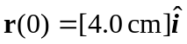, and . Then using the definition of average velocity, 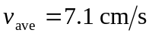 at an angle of 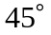.
b) . Substituting for 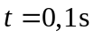, and 2 s, gives:
, and 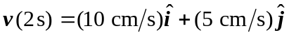. The magnitude and direction of at each time therefore are: 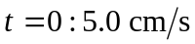 at 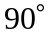; 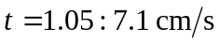 at 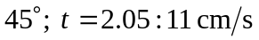 at 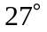.
c)
